1. Adding button to ribbon bar  
   Paste below code in file “FolderButtionbar.xml” which will be in location “C:\InfoShare\Web\Author\ASP\XSL”  
     
   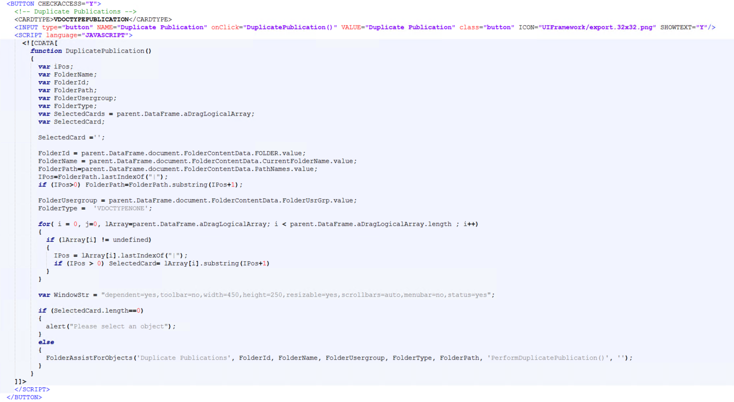
2. JavaScript function to call new ASP file  
     
   Add below code in file “FolderButton.js” which will be in location “C:\InfoShare\Web\Author\ASP\FolderAssist”  
     
   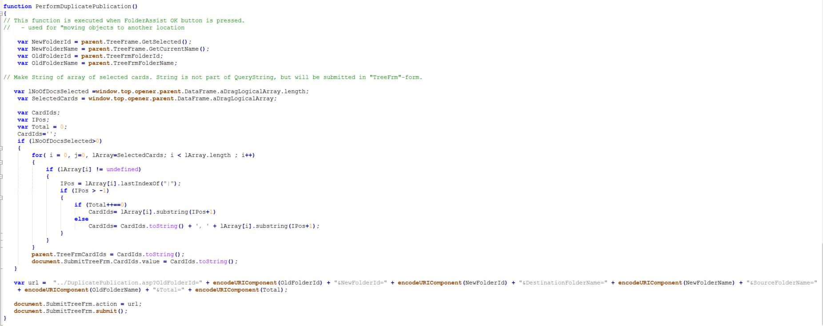
3. Create new ASP file to trigger the event:   
   A new ASP file “DuplicatePublication.asp” is created to call the duplicate background task.
4. Update “XML Background Task Setting” from CM web client with below lines of code:  
    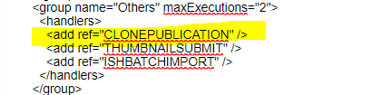  
     
   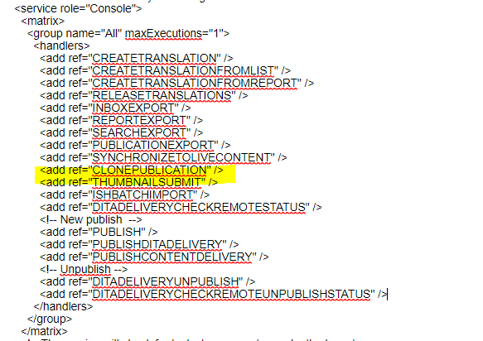  
     
   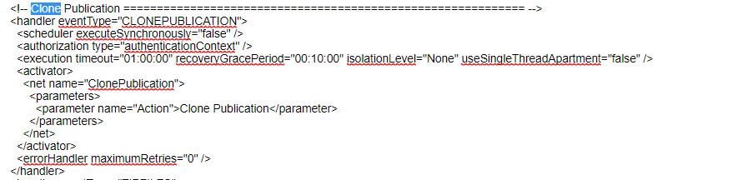  
     
   5. Restart BackgroundTask service and Component services in CM server.